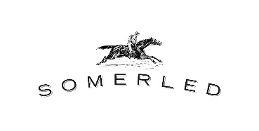
Menu

Anchovy Sticks $14
6 warmed pastry straws
Made in-house by Heather

Cheese Puffs (GF) $14
6 warmed choux pastries
Made in-house by Heather

Sausage & Cheese $20
Chewy cured cacciatore sausage with a
Manchego cheese wedge
Choose Mild or Hot sausage.

Local Bread & Butter $8
Locally-churned butter,
crusty Hills loaf and a dust of salt.
- Add a pot of pate: extra $12
- Add terrine with relish: extra $16

Croque Monsieur $18
Crunchy toasted sandwich
with oozy Manchego cheese,
smoky prosciutto & in-house bechamel.

Spanish Platter $40
Crusty loaf with local olive oil,
Spanish Manchego cheese, sundried figlets, 2 warmed anchovy sticks and local olives.

French Platter $44
Crusty loaf with locally-churned butter,
local pork & herbs terrine, tangy cornichons, local beetroot relish, a local Hills chicken pâté pot
and black charcoal (GF) crackers.

